**GARNET**

**HERO**

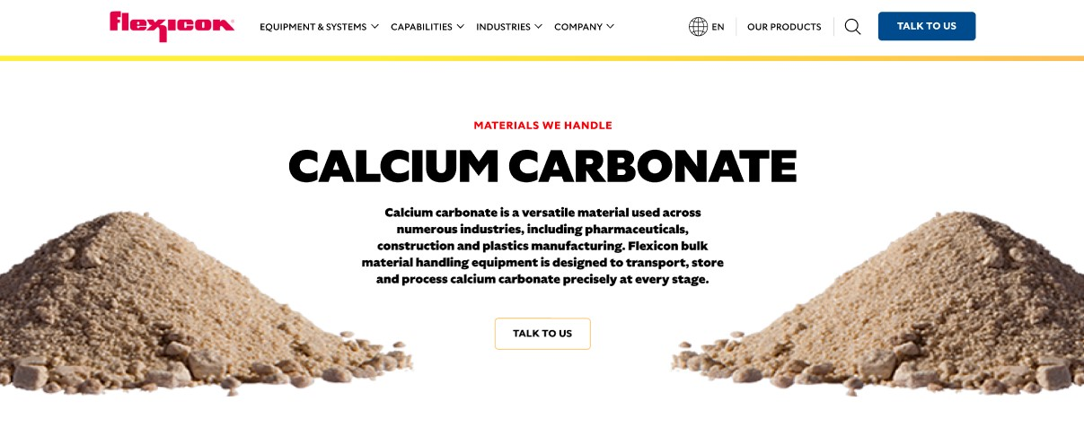

Garnet is a durable mineral commonly recognized as the red-hued birthstone for January, but it also occurs in several other colors. Its unique hardness and angular particle shape make it ideal for industrial applications such as waterjet cutting, abrasive blasting, and water filtration. Flexicon bulk material handling equipment is designed to transport, store, and process garnet safely and efficiently.

**Button**: Talk To Us

**SHELF #1 - PRODUCT DESCRIPTION**

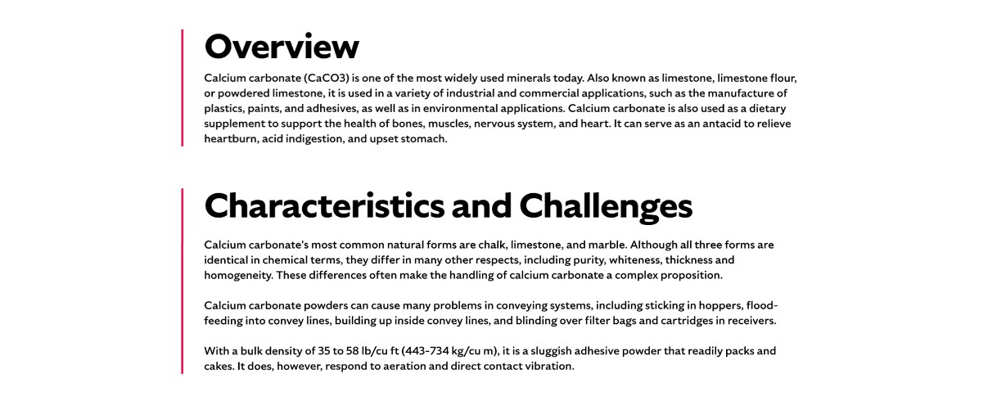

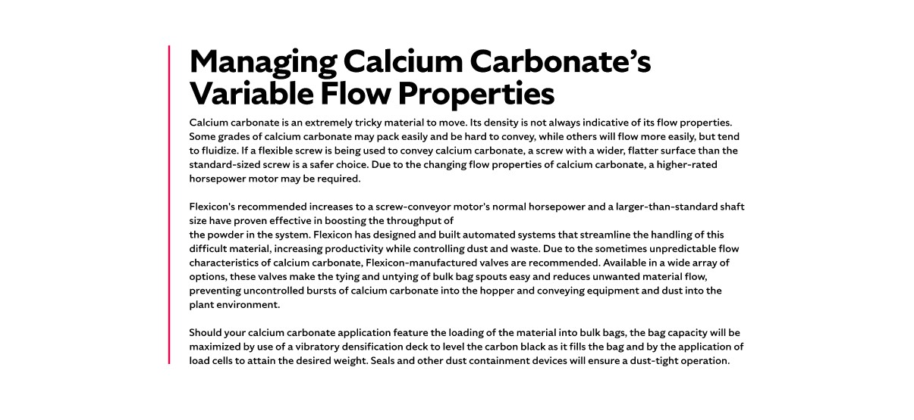

* **Overview**Garnet is generally found inside metamorphic rock formed under high temperature and pressure, which produces its characteristic isometric crystals. Industrial garnet production primarily occurs in India, China, Australia, and the United States, while various types can be found worldwide. Crushing garnet for abrasive applications produces sharp, angular particles ideal for cutting and blasting. Its versatility extends to water filtration granules, abrasive powders, and surface finishing applications, making it a valuable material across multiple industries.
* **Characteristics and Challenges**Garnet has a high hardness of 7.5 to 8.5 on the MOHS scale and is chemically inert, ensuring it does not react with the material it cuts or polishes. Abrasive garnet is classified into blasting grade, waterjet grade, and finer powders for polishing and lapping, with larger grains used for faster material removal and smaller grains for finer finishes. It has an average bulk density of 150 lbs/cu ft (2,406 kg/m³) and is generally free-flowing, though particles can damage equipment if they enter gears or valves.  
    
  Handling garnet requires careful attention to maintain its shape, size, and purity, especially in abrasive applications where particle integrity is critical. Coarser particles tend to interlock, which can impede flow and slow processing, while finer particles may create dust that poses respiratory hazards. Wet garnet can clump, jam, or place excessive strain on conveying systems, so it must be kept dry during transport and storage. Additionally, garnet’s hardness and angular shape can accelerate wear on equipment, making the selection of abrasion-resistant components essential for safe and efficient handling..

**SHELF #2 - FLEXICON SOLUTIONS**

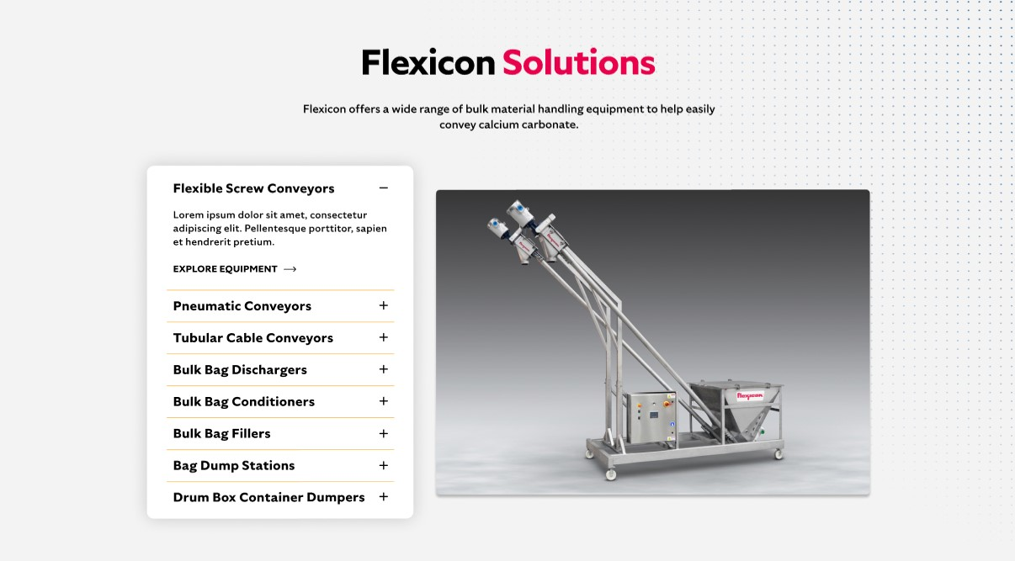

**Flexicon Solutions**

Flexicon offers a wide range of bulk material handling equipment to help easily convey calcium carbonate.

* **Flexible Screw Conveyor**: Move garnet efficiently while minimizing wear and clogging.
* **Pneumatic Conveyors**: Transfer garnet safely through sealed pipelines with controlled flow.
* **Tubular Cable Conveyors**: Convey garnet gently while protecting its angular particle structure.
* **Bulk Bag Dischargers**: Securely empty bulk bags while controlling dust and maximizing flow.
* **Bulk Bag Conditioners**: Stretch and agitate bags to ensure complete material discharge.
* **Bulk Bag Fillers**: Accurately fill bags with garnet while maintaining consistent density.
* **Bag Dump Stations**: Allow safe, dust-contained unloading of smaller bags into hoppers.
* **Drum Box Container Dumpers**: Empty containers efficiently while containing dust and debris.

**SHELF #3: LIFETIME PERFORMANCE GUARANTEE**

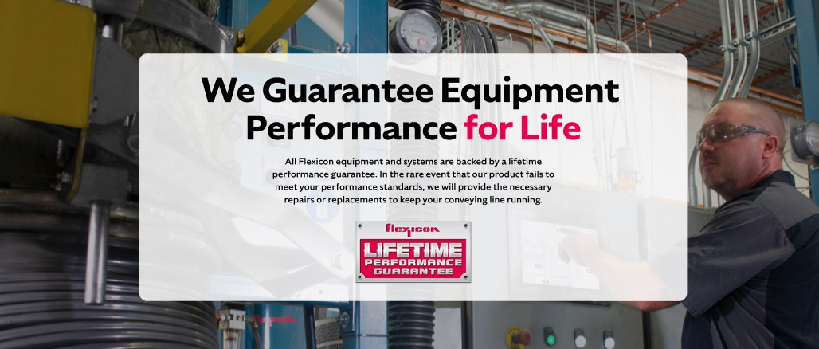

**Lifetime Performance Guarantee**

All Flexicon equipment and systems are backed by a lifetime performance guarantee. In the rare event that our product fails to meet your performance standards, we will provide the necessary repairs or replacements to keep your conveying line running.

**SHELF #4: CASE STUDIES**

